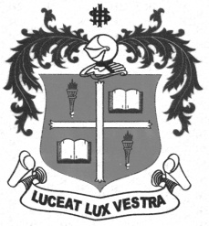
LOYOLA COLLEGE (AUTONOMOUS), CHENNAI – 600 034
B.A. DEGREE EXAMINATION – HISTORY
FIFTH SEMESTER – NOVEMBER 2012

HT 5500 - HISTORY OF FREEDOM MOVEMENT

Date : 01/11/2012 Dept. No. Max. : 100 Marks
Time : 9:00 - 12:00

PART - A

Answer any Ten of the following in not exceeding Ten lines each: (10x2=20 marks)

- All India National Conference
- Madras Mahajana sabha
- Surat split
- Muslim League
- Rowlatt Act
- Dr.Kichlew and Dr.Satyapal
- Chauri Chaura Incident
- 1931 Karachi Resolution
- Poona Pact
- Demand for Pakistan
- Nathuram Godse
- 42nd Amendment to the Constitution
PART - B

Answer any four of the following in about one page each: (4x10=40 marks)

- What demands did Congress make to the British in the beginning?
- Evaluate the reforms introduced by the Act of 1919.
- Comment on the visit of Simon Commission.
- Bring out the features of the Govt of India Act of 1935.
- Write a note on the Partition of India.
- Explain the term ‘Socialist’ given in the preamble of our constitution.
PART - C

Answer any Two of the following in about 4 pages each: (2x20=40 marks)

- Trace the course of the Swadeshi and Boycott movements.
- How did Gandhi bring the masses into the freedom movement?
- Comment on the secular views of Jinnah.
- Describe the salient features of the Indian Constitution.

$$$$$$$

